Naoya HATAKEYAMA (Photographer)
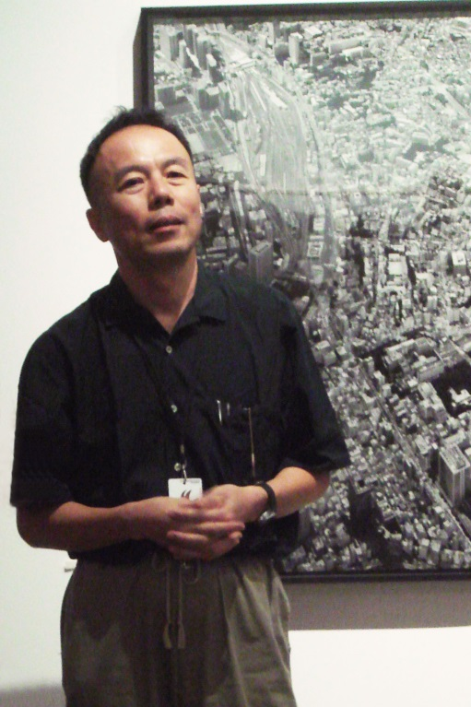
【Hometown】Rikuzentakata, Iwate
【Born】1958
【Education】The University of Tsukuba, School of Art and Design／The University of Tsukuba, Graduate School of Comprehensive Human Sciences, Master’s Program in Art and Design

At high school, he established an art club with his friends who were interested in painting. Later he entered the University of Tsukuba, and studied
Photography under supervision of Kiyoshi Otsuji in Visual Communication Design course.
In his works, he puts his main focus on a relationship between nature, city and photography; he publishes his
photo: Marc Feustel
works which captures coal mines, factories, digging sites and their explosion, or architectures and underground waterways in urban areas.
【Bibliography】
1996 Received the 22nd Kimura Ihei Award with a photo book “Lime Works” and exhibition “Maquette of City”
2000 Won Higashikawa Award, Domestic Photographer Prize
2001 Had an exhibition at Japan Pavilion in Venice Biennale with Masato Nakamura and Yukio Fujimoto
Received Mainichi Culture Award with “Underground”
2002 Hold “Exhibition of Naoya Hatakeyama” at Iwate Museum and National Museum of Art, Osaka
2003 Received Photographer of the Year Award from the Photographic Society of Japan
2012 Received Minister of Education, Culture, Sports, Science and Technology Award for Fine Arts with his solo exhibition “Natural Stories”
Won “Golden Lion” Award at the 13th Venice Biennale, section of International Architecture Exhibition Japan Pavilion
2013 Hold an exhibition “BLAST” at Taka Ishii Garelly
2014 Had an exhibition in “City and Nature” at Sapporo International Arts Festival 2014 (Hokkaido Museum of Modern Art)

